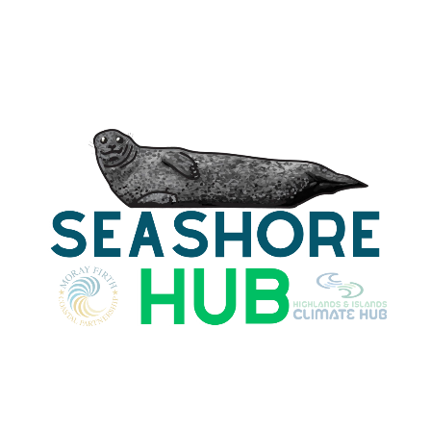
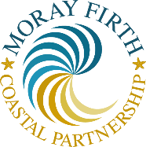
Seashore HUB:
Become a Seashore Litter Picking Hub Spot
Adopt a Beach!

What is the Seashore Hub?

The stretch of coastline that covers the Moray Firth is vast, with many variations in both physical appearance and impacts of marine debris. To continue keeping our coastlines healthy, it is important that we establish a cohesive approach to bring together communities to tackle the issue. This project will look to equip communities with the resources they need to assist in a collaborative approach to beach cleaning.
The HUB spots will create a space to borrow equipment to collect data on marine litter along the Moray Firth coastline. The HUB spots will make beach cleaning accessible to anyone that is in the area that wishes to partake in a beach clean. Those checking out the equipment can choose to take a beach cleaning data collection form or to conduct a volume clean, in which the aim is to collect as much litter as possible.
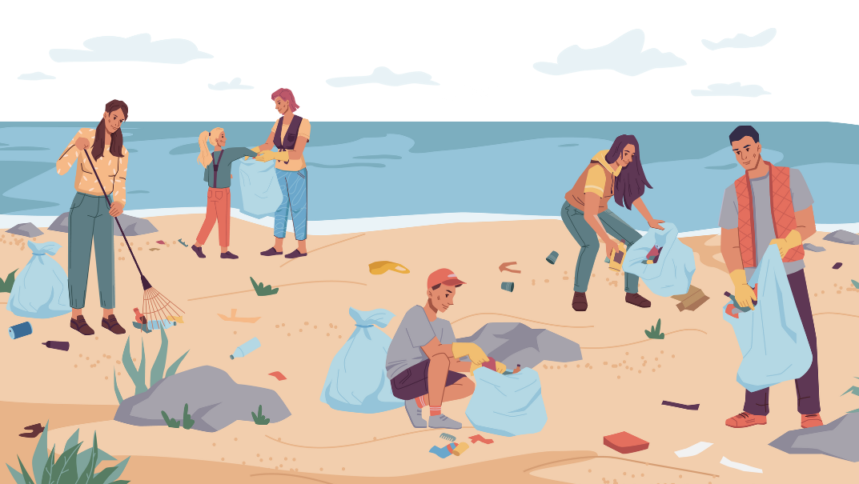
We are currently investigating a pilot project focused on upcycling marine litter in the Highland region of the Moray Firth during our dedicated beach cleaning activities. With a commitment to combatting ocean pollution, we have embarked on a mission to transform the discarded waste found on our shores into valuable and sustainable resources. Through this project, we aim to raise awareness about the detrimental effects of marine litter while actively engaging local communities in hands-on environmental stewardship. By collecting and repurposing items such as plastic bottles, fishing nets, and potentially other debris, we hope to promote a circular economy but also encourage a shift in perspective, turning marine litter from a problem into a solution. This will help us as we work together towards a cleaner, healthier, and more vibrant coastal ecosystem.

What do I need to become a HUB spot?
Somewhere to store equipment: We have received funding to provide beach cleaning equipment boxes so that the equipment can be kept outdoors and easily accessible. You will be in charge of making sure the storage boxes are locked at the end of each day.
Attend training day: We will provide a training day on your local beach to provide the HUB and any locals wanting to find out how to beach clean to spread the word that there is equipment available at a facility nearby, you must be able to attend training.
Commit to getting involved: We need you to be the guardian of your specific stretch of land! We want you to take pride in keeping your coastline clean and engage with your community to promote beach cleaning and borrowing your equipment.

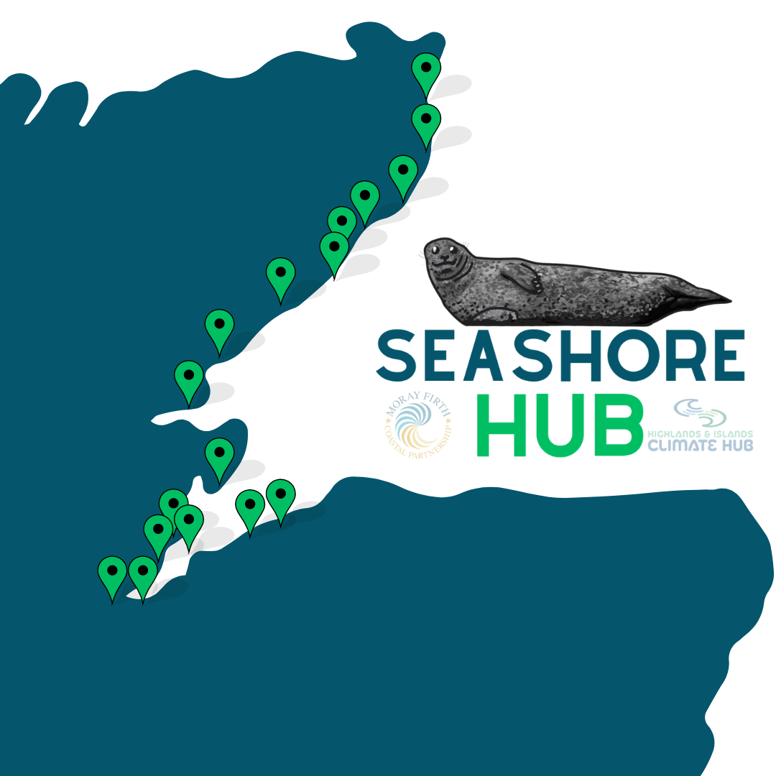

Expression of Interest

Please use this form to submit an expression of interest in a becoming a Moray Firth Seashore Hub Spot. Before completing this form, you may find it helpful to read the information on the Seashore Hub and everything that is involved with the project. Where the Expression of Interest is being submitted on behalf of an individual or an organisation working in a consortium or partnership, please provide relevant information for all of the organisations involved.

If you wish to submit any other documents with your Expression of Interest, please ensure that these are listed at the end of this form.

Name of organisation(s) / business/ relevant individual:
Main contact name and address:
(Including email address). Please note that all correspondence relating to the Expression of Interest will be sent to this contact.
Please provide an overview of the area in which you would like to cover.
(Around 5 miles of coastline would be preferrable - Please provide rough location points for the start and end of where you would like to cover as a Seashore Hub)
Please provide details of public opening times (or availability for equipment collection) and whether you currently have space to store a beach cleaning pack (indoors/outdoors?)
(packs include litter pickers, gloves, bin bags, hoops, laminated info sheets, and a sign out folder)
Please provide confirmation that you will be able to provide contact details for public display for potential litter pickers to sign out equipment (name, phone number, email, address & opening times)

Please advise us of the reason in which your business/organisation would like to be part of the Seashore Hub Network.

Please give details of the availability and potential for self-organised litter picks with the supplied equipment. Would you be able to commit to completing at least 4 beach cleans a year?

What outcomes would you seek to achieve in running the service? Please make specific reference to:
- Cleaning the coastline of the Moray Firth
- Increasing community engagement around the preservation of the marine environment
Please refer to any relevant work or involvement in conservation or beach cleaning activity, including any that you have carried out previously.

Please note here any attachments which are included with this form:

I confirm that the information contained within this form and any appendices are a true and accurate representation of the organisations submitting this Expression of Interest.

Signed:

Position:

Date:

